PSAC Calgary Human Rights Committee
presents a limited time offer…
Our sponsorship of this event, GlobalFest 2012, has offered exclusive discounted pricing to the friends and members of PSAC for their 10th Anniversary Celebration at Elliston Park.
$7.50 per General Admission Ticket
(August price: $15.00, tickets are “date” specific)
$30.00 per GlobalPass - for all six (6) nights
(August price: $75.00, single entry for all six nights)
Dates for GlobalFest
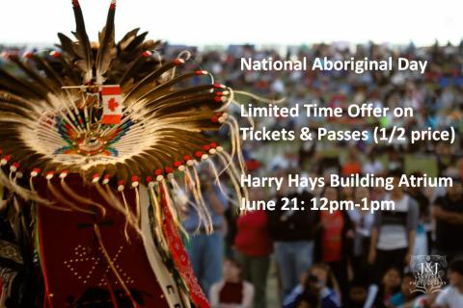Thursday, August 16 – Philippines (2011 People’s Choice)
Saturday, August 18 – Mexico
Monday, August 20 – China
Wednesday, August 22 – Brazil
Friday, August 24 – USA
Sunday, August 26 - Finale
**Offer valid until July 31st, 2012.
To place orders contact the following:
Contacts from the Calgary Human Rights Committee:
Timothy Hunt ( Timothy.Hunt@cbsa-asfc.gc.ca ) or (403) 292-4150
Evelyn Egger ( Evelyn.Egger@cra-arc.gc.ca) or (403) 508-5728
Garth Caron ( Garth.Caron@rcmp-grc.gc.ca ) or (403) 699-2662
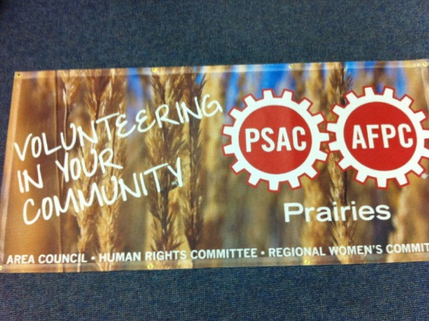Volunteering for this Event (includes admission to the park)
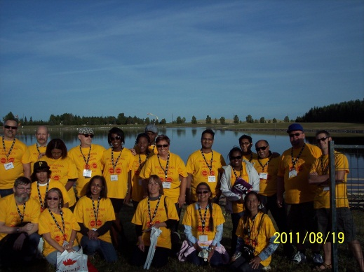The Calgary Human Rights Committee is also looking for volunteers for the following:
August 16th – Swearing In Ceremony
> Volunteers from 4:30pm-8:30pm > to assist invited guests from Immigration Canada to the gathering point in the park
August 18th to 26th – Aboriginal Village
> PSAC members are needed to help operate the display from 6pm to 9pm for the PSAC Booth & TIPI discussing what the union involvement is with regards to Aboriginal issues in Canada and pass out information to the general public.

