Have you ever wanted to take part in the
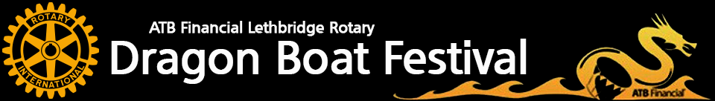
But haven’t had the chance to do so yet? Too pricey? No experience?
Here’s your chance!!
We are looking for novice and experienced paddlers to join the first ever Public Service Alliance of Canada’s “We Are All Affected” team at this year’s Dragon Boat Festival the weekend of June 26th to June 28th.
With support of the PSAC Area Council registration is FREE and includes:
- Two 1 hour practices* (Thursdays June 11th and June 18th @ 7:25pm) *subject to change based on availability.
- Minimum 3 races (Friday June 26th – Sunday June 28th)
- Race weekend tent for you and your team mates
- We Are All Affected T-shirt
- A great festival weekend complete with beer gardens, games for the kids and entertainment
If interested in joining the team... please contact Krysty Munns @ munnsk@gmail.com by Friday May 29th.
All practices and race weekend takes place in Lethbridge, AB at Henderson Lake. More info @ www.lethbridgedragonfest.ca
