Winnipeg and Area Human Rights
Community Activism
Manitoba Legislature (11:00 am)
Sunday, June 1, 2014
Rally (11:00 am) then Parade (12:00 pm) Festival at the Forks (1:00 pm – 6:00 pm) http://www.pridewinnipeg.com/
Pride Winnipeg 2014 “Without Borders”
The theme takes its cues from LGBTTQ* history, the celebration of hard-won victories for equality and justice, a vision of equality for all, and a deep desire to make real change at home and abroad. The theme is centered on the overarching theme of Pride itself: of being “Out and Proud” as a group, as a movement, and as an ideal. To encourage others to be unashamed of their identity and to march proudly. It’s concentrated on the vision of a world WITHOUT BORDERS both in a global sense for justice and equality, and also in a personal sense, for freedom of one’s own expression without barriers.
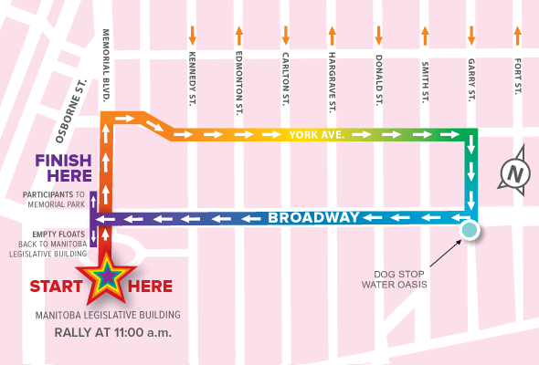
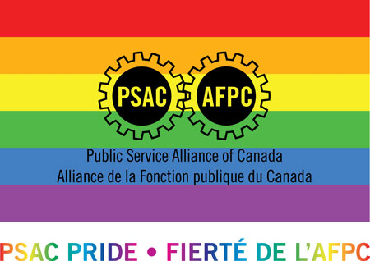
Winnipeg and Area Human Rights Committee
http://prairies.psac.com/areas/winnipeg/human-rights-committee
All are welcome: Any PSAC member, friends and family, can come and march with PSAC in the parade. To find us please walk around the Manitoba Legislature building and look for the PSAC logos, or join us when we start the march.
Any questions? Feel free to contact the chair of the committee: Christopher.Little-Gagne@une-sen.org
* The asterisk represents other minority gender identities and sexual orientations

