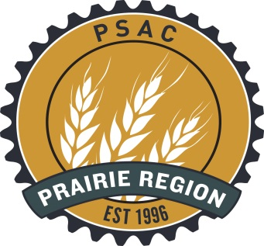

Winnipeg and Area Human Rights Committee
175 Hargrave Street (4th Floor)
PSAC Regional Office

Seasonal Celebration for all PSAC Members
Tuesday Dec 15, 2015 from 5 pm to 7 pm (doors downstairs lock at 6) PSAC office at 175 Hargrave St Unit 460
Please RSVP to parrl@psac.com or call 204-947-1601
The Winnipeg Area Human Rights Committee, Winnipeg Area Council and Winnipeg Women’s Committee would like to invite all members out on Tuesday December 15th, 2015 for our annual seasonal celebration.
There will be a guest speaker (from Siloam Mission), food, celebration and members from each committee to ask questions. Let’s get together to celebrate the positive achievements that have been made over the last year.
If your local would like to donate a door prize feel free to contact Chris Little-Gagné for more information or drop the door prize off at the PSAC Regional Office.
Please bring a donation to help those less fortunate.
(https://www.siloam.ca/wp-content/uploads/2013/02/Ongoing-Needs.pdf)
If you are unable to attend donations can be dropped off to the PSAC regional office in advance or to Siloam Mission.

You Can Help Make Change Happen!
Every day, hundreds of people experiencing poverty and homelessness in Winnipeg walk through the doors of Siloam Mission. Some come seeking a nutritious meal, a warm bed, or fresh clothing. Some struggle with illness, disability, addictions, or feelings of rejection and loneliness. Everyone is looking for compassionate hands, listening ears, and a second chance.
At Siloam Mission, we see change happening in the lives of people in our inner city every day. You can connect with others in your community and change a life today.
Winnipeg and Area Human Rights Committee
http://prairies.psac.com/areas/winnipeg/human-rights-committee

Any questions? Feel free to contact the chair of the committee: Christopher.Little-Gagne@une-sen.org

