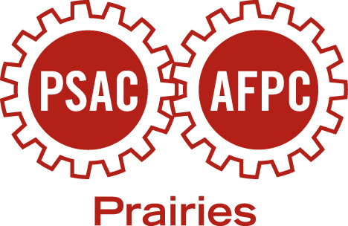
Public Service Alliance of Canada (PSAC) Winnipeg Regional Women’s Committee
6th Annual School Supply Drive

From May 2012 to the end of September 2012
Manitoba PSAC Locals/Branches

The PSAC Winnipeg Regional Women’s Committee (RWC) invites your local/branch to participate and collect school supplies over the summer. Locals/Branches in the past have held collection drives in their workplaces for school supplies.

If you local/branch chooses to donate funds instead of collecting supplies, you may mail or drop off a cheque* to:

PSAC Winnipeg Regional Women’s Committee
Winnipeg Regional Office
Suite 460- 175 Hargrave Street
Winnipeg MB R3C 3R8

*cheques made to the ‘PSAC Winnipeg Regional Women’s Committee’.

PSAC Members Supporting Children’s Education
Since, 2009 over 70 boxes of school supplies have been gathered and donated by PSAC members in Manitoba. These supplies have been distributed to 40 plus schools and funds raised have supported Winnipeg Inner City school lunch programs.

Together we can make a difference!!!

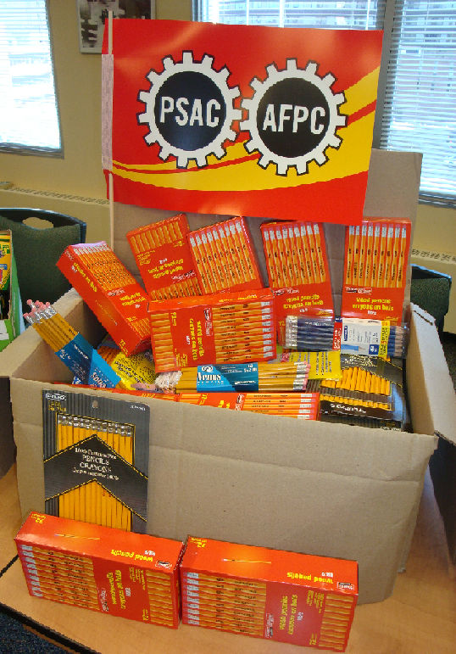
Contact the PSAC Winnipeg Regional Office for questions, (204) 947-1601.

In Solidarity,

PSAC Winnipeg Regional Women’s Committee

For more information contact:
Deanna Kimball-Cook,
PSAC Winnipeg Regional Rep

(204) 947-1601 or kimballd@psac.com

