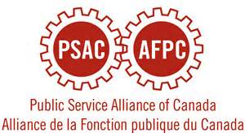

The Regina Regional Women’s Committee is hosting a Women’s self-defence class. All women are welcome.

Date: April 18th, 2015

Session 1: 9:00 am – 12:00 pm

Session 2: 1:00 pm – 4:00 pm

Where: Eastview Community Center 615 6Th Ave Regina

Registration is required and can be done at <http://prairies.psac.com/events/regina-womens-committee-self-defense-training> or by calling 306- 757-3575 by April 2nd, 2015.

A suggested of donation of $ 10 is greatly appreciated and will be donated to Sophia House.