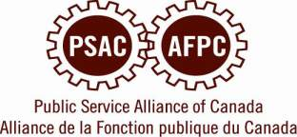

WESTMAN AREA COUNCIL MEETING

Wednesday July 8, 2015
5:00 pm at Brandon Labour Council Boardroom
C-727 10th Street

Agenda

- Prairies REVP Marianne Hladun
- Alternate REVP election
- Regional action planning and upcoming United Way events
- BDLC Labour Day BBQ
- MFL convention updates

Please RSVP your attendance or
regrets by contacting:

Jennifer Grant at 721-0803
or
jenniferinmanitoba@hotmail.com

*For members from outside of the Brandon Area, commuting assistance may be provided. Please advise if you are travelling further than 75 kms one way to attend.

